Franco Emanuel González Sánchez

# COMPUTER VISION

**EXERCISE 0: Introduction to Matlab**

Concepts: Image loading, saving, and conversion.

1. Simple image manipulation:
   1. Load the color image **lily.tif**,

im = imread('imagenes\lily.tif');

* 1. convert it to grayscale,

im2 = rbg2gray(im);

* 1. show its histogram and

imhist(im2);

* 1. save it as **lily_gris.tif**.

imwrite(im2,'imagenes\lily_gray.tif');

**Result:**

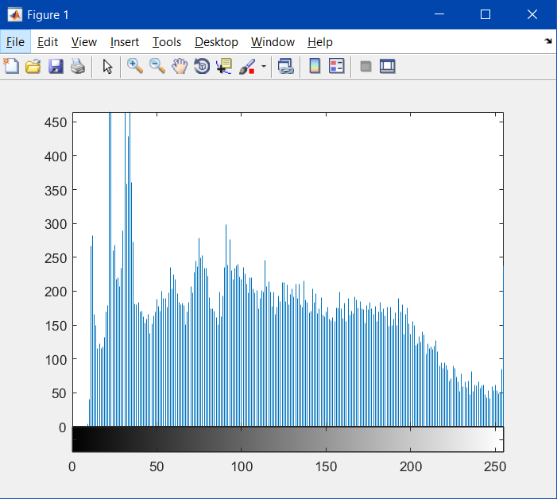

The histogram shows the quantity of each scale of grey in a grayscale image. Here we can see there is more darks zones than light ones.

1. Implement a *script* file showing in the screen, in a subplot:
   1. The initial **lily_gris.tif** image.

im = imread('imagenes\lily_gray.tif');

* 1. Binary image from thresholding it (threshold=100).

im2 = im2bw(im,100/255);

* 1. Image with half resolution.

im3 = imresize(im,0.5);

* 1. Middle part of the image with half the size.

x = size(1);

y = size(2);

c = [x/4, y/4, 3*x/4, 3*y/4];

im4=im(c(1):c(3),c(2):c(4));

**Result:**

